Format #2: Essay Format
- Unless you are actually doing a separate cover sheet or title page, the first information on the first page of the essay is the teacher and student and course names and so on. [Insert] auto page numbers in the header/upper right hand corner. Don’t do it manually.
- Essay titles benefit from a colon. To the right of the colon, you give extra information. (e.g. George Milton: Small Man, Big Dreams) You may center and/or bold your title if you want, but leave it Times New Roman size 12. Use the colon. The same title rules apply for formats #2 and #3 as for format #1. Make your title specific enough that it would be wrong on another student’s work. There are words you should not use in your title because they are not specific enough and will make it boring. For example “Writing Assignment” or “WWII Essay.” Don’t.
- Size 12 font. Times New Roman only. (No Arial, Calibri or anything else. At all.)
- Double-spacing. This allows teachers to write on it, when printed on paper.
- Paragraphs are left justified (align left).
- Simple high school essays often have five paragraphs, because of needing introductory and concluding paragraphs, plus three body paragraphs. More advanced essay work will require many more paragraphs than five. They break the page up and make it more comfortable to read. No page-long paragraphs. Each page needs two or three. Headings and section breaks can help if there are pages and pages of paragraphs.
- It is important to indicate titles of the works discussed. Put them in italics if they are complete works like novels, plays, movies, video games, music albums and TV shows. Use “quotation marks” for smaller bits of them, like short stories, chapters, scenes, poems, video game levels, individual songs, or individual episodes of a TV show. So you would write “William Shakespeare’s Hamlet.” But you would write “I was playing the “Zombie Apocalypse” level in Call of Honour.” or “I like the song “Black Sabbath” on the Black Sabbath album by the band Black Sabbath” or “I watched the “Days Gone Bye” episode of The Walking Dead.”
- Indent all paragraphs. Indents are five spaces achieved with a single press of [Tab]. Setting the rulers at the top in Word allows you to make it auto-indent 5 spaces for you automatically.
- Cite sources on a separate Works Cited page titled “Works Cited.” Use MLA format for English courses, and APA for most other courses, with the sources alphabetical by author’s last name. Note sources after quotes by putting, in brackets, Author Last Name, a “p” and the page number: (Jones p25).
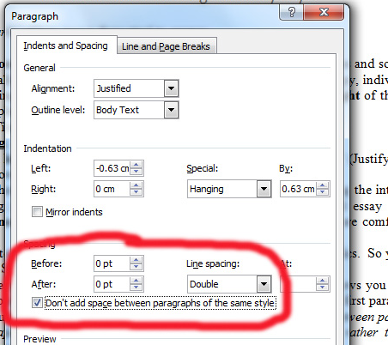
- No blank lines of empty space between paragraphs. This is because leaving those wastes paper, and you also need them to divide groups of paragraphs into subsections. Possibly with headings. You’re doing indents instead. So don’t use whitespace after every paragraph. You need them for something else. For Format #2, ensure your paragraphing in Word is set up like this:

