Journal Work for Of Mice and Men (2P)
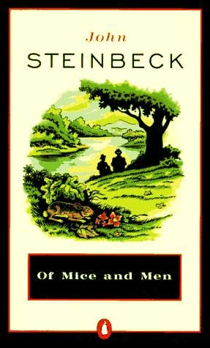
Note: this assignment is to be hand-written, if possible. For every chapter of Of Mice and Men, you will do the following:

- You will make a title for each chapter. (Steinbeck didn’t even put “Chapter 2” at the top of his chapters.) Write something like Chapter 3: Curley Buys a Car. Use the colon.

- You will write a one-sentence summary of the major events that occur in the chapter, starting with the words in “In this chapter, Steinbeck...” Use present tense and “ing” (put “In this chapter, Steinbeck describes George going” or “In this chapter, Steinbeck depicts Lennie finding” or “In this chapter, Steinbeck reports Curley saying” rather than “Steinbeck wrote that George went” or “Steinbeck had a part where Lenny found” or “Steinbeck described how Curley said.”)

- You will then write three of the following ‘sentence formulas’ (in the box below) for each chapter, filling in the appropriate details (by the end of the book, make sure you’ve tried out most of these. Use “once again” if you said something similar in previous chapters). Separate the three ‘sentence formulas’ into their own paragraphs with indents. If you leave a line of blank space between paragraphs, you must fill each blank line by writing “I will use indents to indicate paragraphs, rather than leaving a line of blank space” in it. Use the square brackets to change all of the verbs in your quotations into present tense to match your (present tense) sentences:
Steinbeck (once again?) alludes to Lennie being apt to get into trouble. This can be clearly seen when he writes that “ Lennie [has] gotten caught shoplifting another magazine.”

In typical fashion, Steinbeck chooses to have the very thing that would make a character happy taken from him. __Geoff’s fondest wish is to become a ballet dancer. Steinbeck shows how this dream is shattered when he writes that “Geoff [can] not dance anymore. His leg [has] been torn completely off by the thresher.”

Steinbeck (once again?) alludes to George having to make personal sacrifices to take care of Lennie. He has George say that “’If [he] didn’t have to look after [Lennie], why [he] could go to that damn truck show!”

Steinbeck shares something about Jim which makes the reader dislike him somewhat. Steinbeck elicits this response by writing that Jim “ [walks] in the door and [kicks] the puppy.”

Steinbeck makes the reader feel a bit sorry for Tom in this chapter. Steinbeck accomplishes this when he writes that Jim “ [walks] over and [steals] Tom’s milk money.”

Steinbeck characteristically describes his settings as peaceful and beautiful, while the events which are going on in them are often the very opposite. He describes the shed by saying that “shafts of dappled light [shine] through the leaves, making a golden wonderland of the shed.” The whole while he is describing the shed in these idyllic terms, _Jim is torturing Geoff in the shed.

Steinbeck uses this chapter to further convey to his readers the grim realities of the Great Depression, and how hopeless and lonely were the lives of many who lived at that time. Steinbeck does this by explanation. Follow the Stop! Sheet perfectly. No quotation, but include specifics. Names, places, events.

Unusually, Steinbeck for once depicts a character being nice and helpful in this chapter. Geoff introduces Lenny to everyone who is watching hockey on TV. This clear when Steinbeck writes that Steve says “Come on in,” ... “We’re just watching the Habs.”

Steinbeck uses this chapter to explore his conviction that in the 1930s, the American Dream of every American being able to rise up from poverty and achieve success, is no longer a realistic notion. Steinbeck does this by explanation. Follow the Stop! Sheet perfectly.

Chapter 3: A New Hat
In this chapter, Steinbeck describes George going into town and buying a new hat, but getting into an argument with Geoff over how much it costs.
Typically, Steinbeck chooses to have the very thing that would make a character happy taken from him. Geoff’s fondest wish is to become a ballet dancer. Steinbeck shows how this dream is shattered when he writes that Geoff “[can] not dance anymore. His leg [has] been torn completely off by the thresher.”
Steinbeck reveals that George feels he has to make sacrifices in order to take care of Lennie. He has George say that “If [he] didn’t have to look after [Lennie], why [he] could go to that damn truck show!”
Steinbeck shares something about Jim which makes the reader dislike him somewhat. Steinbeck elicits this response by writing that “Jim [walks] in the door and [kicks] the puppy.”

