Personal News: This December
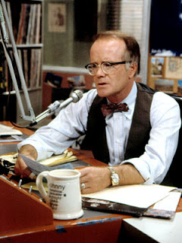
I often hide instructions in the italics at the top of the page. In these italics I have hidden the usual instructions not to ask me how long this should be, and also that you should use format #3, only with two columns for your page to look more like a newspaper or magazine article. For this one, I will not be helping you find your mistakes. I am counting on you to find them yourself, and perhaps also to have someone else help you proof-read it. The idea is for this submission to show improvement over September’s work without needing my help.
Headline
Your headline will start out with the name of the month you’re mainly discussing, then a colon, then some kind of phrase summing up your month. So it could say:

December: Babies, New Car and Hockey

Show me you know to consistently use all (or no) capital letters for words in headlines. Be sure that your overall headline is very large, and that your bold headings underneath aren’t quite as big.

Two Sentence That Go Under Your Headline
In the world around, __________, __________ and __________ were top news stories in December of 2018. In my world though, the most important events involved ________, _______ and _______.

Additional instructions: use “ing” verbs in the phrases you write in those blanks. Make sure you have a minimum of three “world around” news stories from the month, and another three “my world though,” stories. You will not have room in this crowded sentence to actually tell much about the stories.

In the world around, America bombing Syria, Justin Bieber getting arrested and Apple releasing a new iPhone were top news stories in December of 2018. In my world though, the most important events involved my sister having her baby, my dad buying a new car and my team almost winning the championship.

News Stories
In the above example, you will not then go on to report on Syria, Bieber or Apple. You will write a section for each of your (minimum of three) “my world/personal” stories with a bold headline that sums up what happened. Then underneath you will tell the whole story. Follow a three paragraph style for each personal story. Beginning, middle, end. Setup, the event itself, the aftermath. If you go into more detail, you can use more than three paragraphs per story. I also want some kind of picture for each story.

Counting the Various Things I Asked For:
1 headline with a colon. The largest font on the page
Format #3, but with columns (2)
3 current events news stories referenced, using “ing” verbs
3 “my world” personal stories referenced, using “ing” verbs
3 personal story headlines. Large font for each, which contrasts with your body text.
3 paragraphs for each of the personal stories, minimum, making at least 9 personal story paragraphs
3 pictures (these could be drawn or taken by you, if you like to do that)

